College Fest Debate Competition

Participants List

**URL : http://localhost:8090/CollegeFest/debate/participantslist**

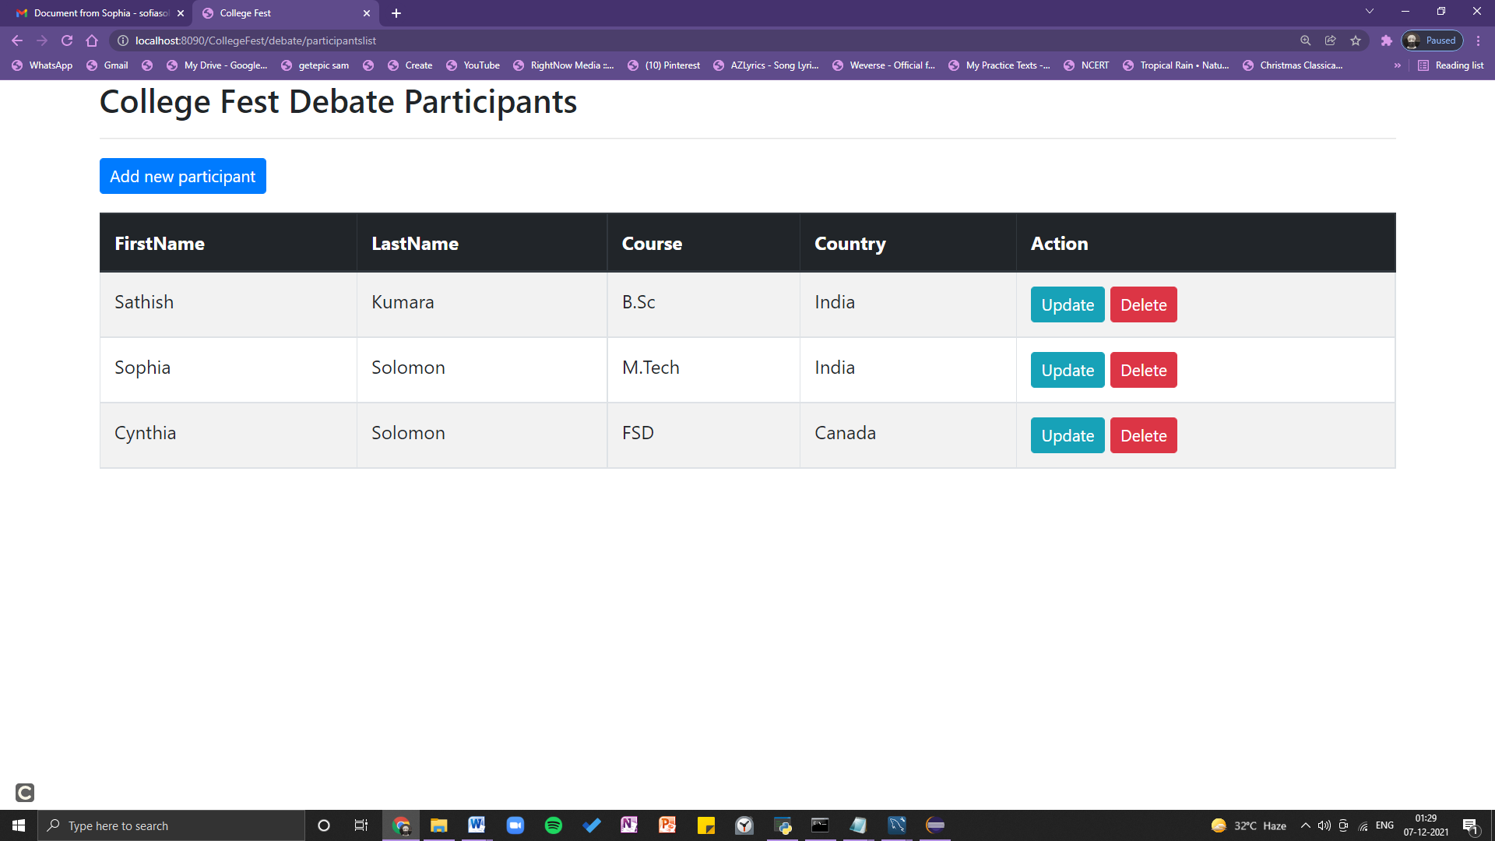

Participants details update

URL - http://localhost:8090/CollegeFest/debate/updateParticipantDetails?studentId=2

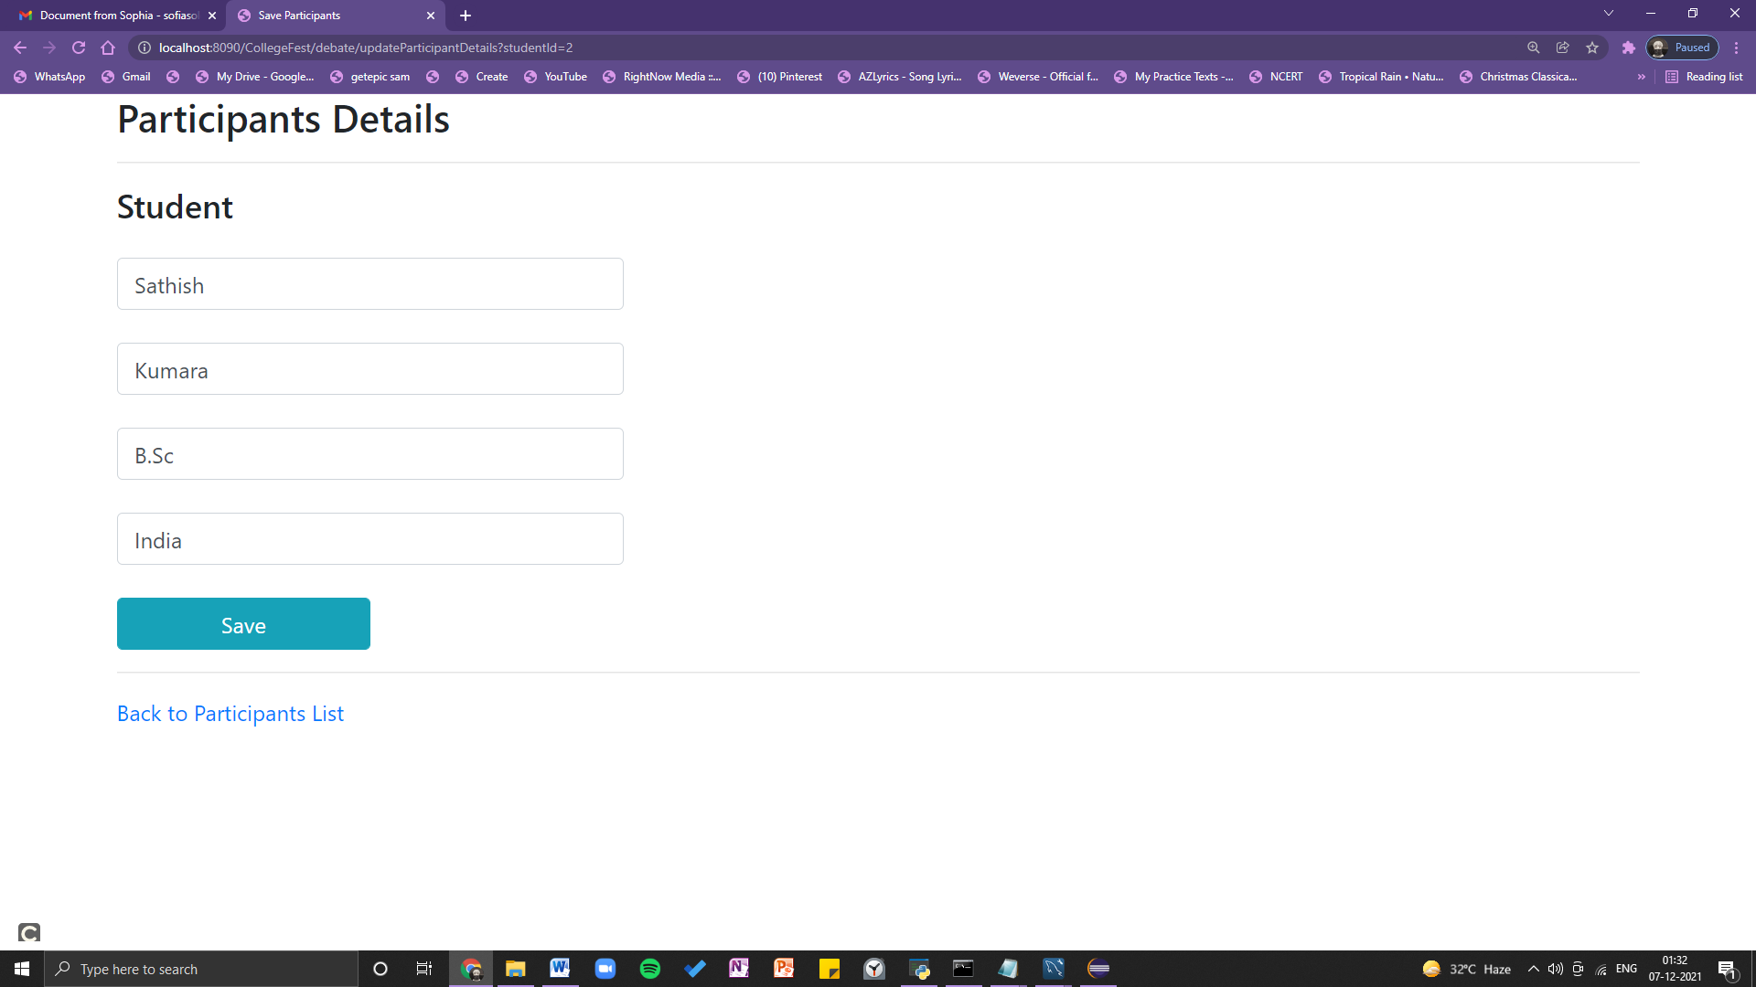

Delete Participant

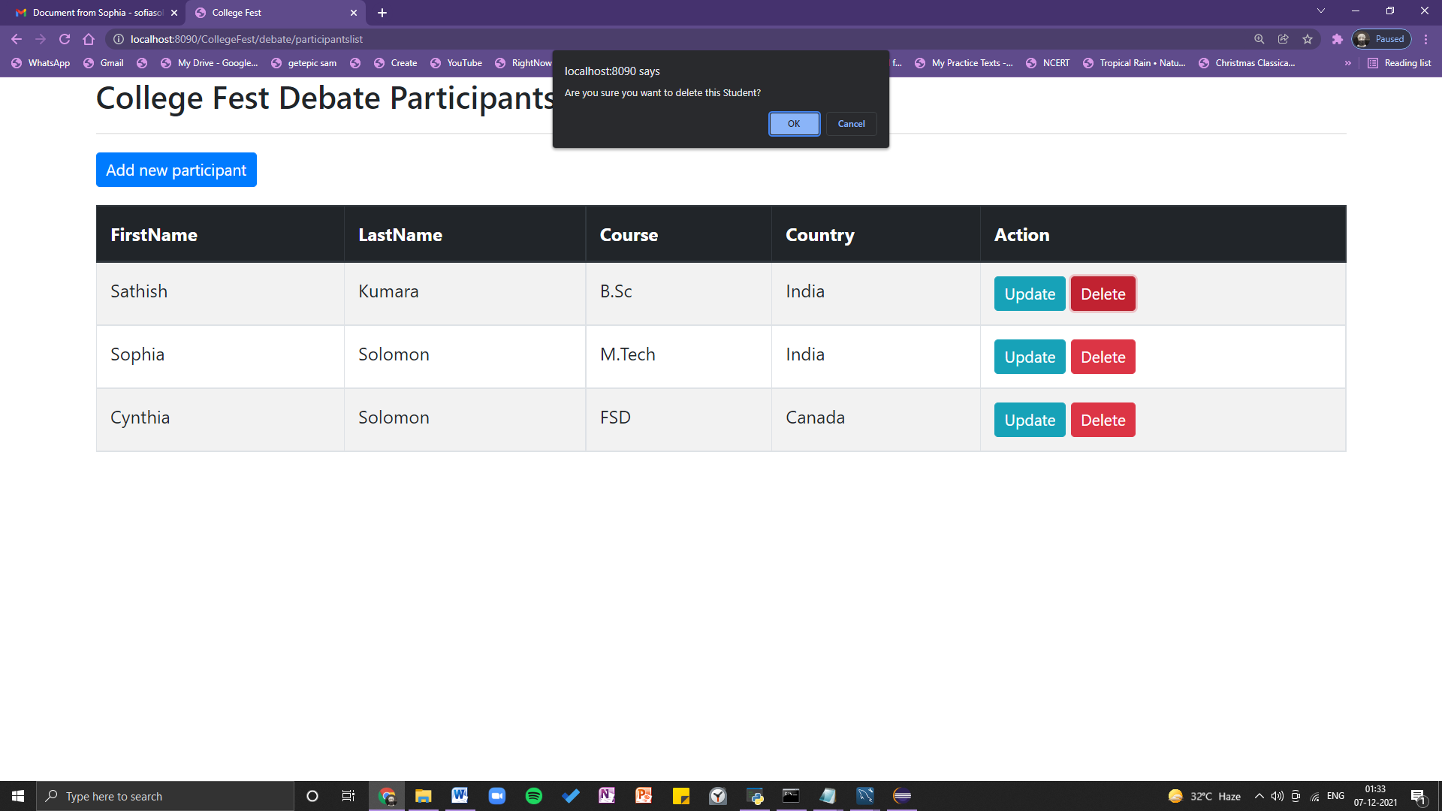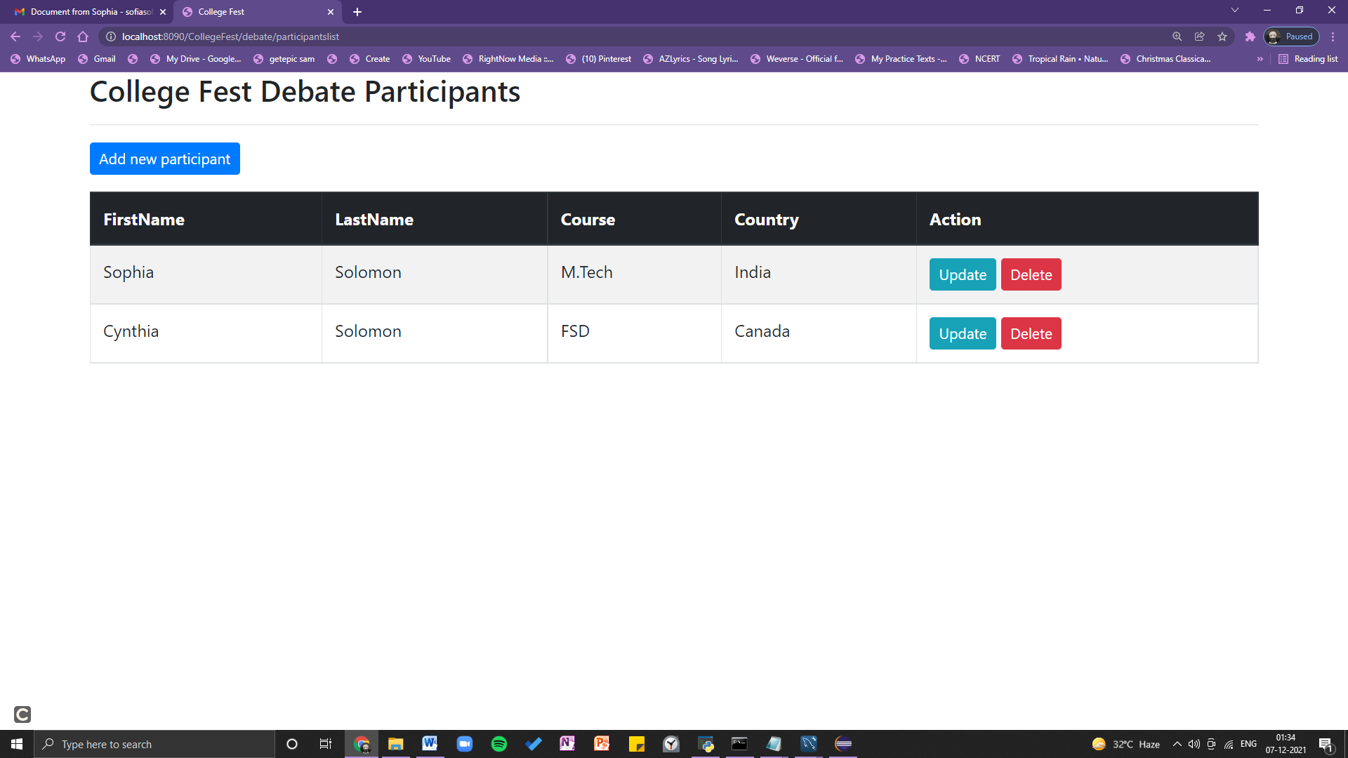

Add Participants

URL - http://localhost:8090/CollegeFest/debate/addParticipantDetails

